**Your FAFSA has been chosen for Federal Verification and you need to provide a SIGNED a copy of your 2023 Federal Tax Return to the SCCC Financial Aid Office. Make sure to physically SIGN this copy and include all schedules! You do not need to request an IRS transcript for Federal Verification purposes if you can provide a SIGNED copy of your 2023 IRS Tax Return.**

If your FAFSA has been selected for State Verification (NJHESAA Verification Regulations require an official IRS Tax Transcript, they will not accept signed copies of the tax return) or IF YOU NO LONGER HAVE A COPY your 2023 tax return, you will need to contact the IRS for a copy of your **2023 Tax Return Transcript.**

**Requesting an IRS Tax Return Transcript for 2025-2026 Academic Year**

1. **Go to** [**www.irs.gov**](http://www.irs.gov) **and choose**

**“Get Your Tax Record.”**

1. **Select “Get Transcript Online” to print from home OR select “Get Transcript by Mail” to have it sent to you.**
2. **Hit OK and complete the form with your information making sure your street address exactly matches the one on your tax return.**
3. **Select RETURN TRANSCRIPT as the type of transcript.**
4. **Select 2023 as the tax year.**
5. **Make a copy of your transcript and submit to the SCCC Financial Aid Office or NJHESAA as requested. Be sure to include your SCCC ID# or NJHESAA ID.**

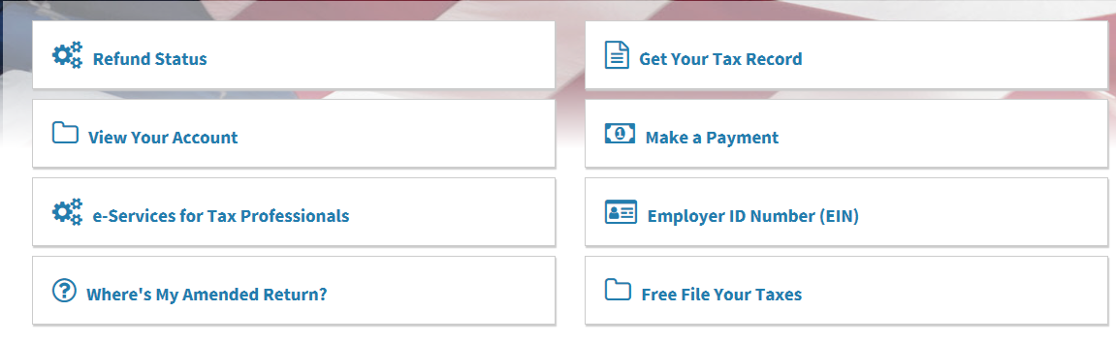

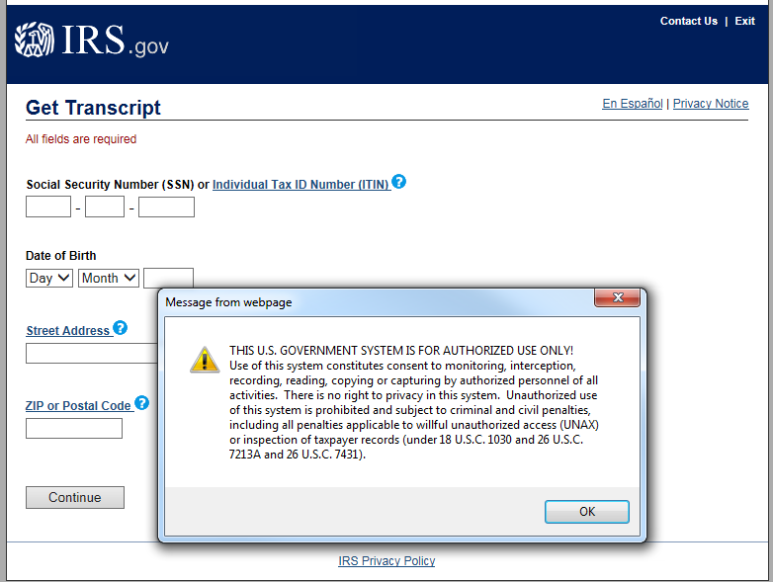

If you are unable to obtain your tax transcript online, you can use the IRS automated phone tool at (800) 908-9946 or mail IRS Form 4506 or 4506-T to the IRS. (The 4506-4506-T forms are available online at [www.irs.gov](http://www.irs.gov).

**Turn in required forms or documents to the SCCC Financial Aid Office in one of the following ways:**

* US Mail: SCCC Financial Aid Office B212, 1 College Hill Road, Newton, NJ 07860
* Fax: 973-300-2224
* On Campus – Use the Locked Drop Box in the B-Building Hallway outside the Financial Aid Office (B212). Place your documents in a SEALED ENVELOPE and write your name, ID number and phone number on the envelope in case we have any questions.
* Call our office at 973-300-2225 if you have issues submitting documents or forms.

**If required for NJHESAA, please submit directly via NJHESAA’s MappingXpress Secure Document Upload:**

* [**https://www.hesaa.org/Pages/GrantsUpload2022-2023.aspx**](https://www.hesaa.org/Pages/GrantsUpload2022-2023.aspx)